Name: ______________ EXERCISE – Grade 4
Class: _______

- Look and complete the words.
3.
1. | 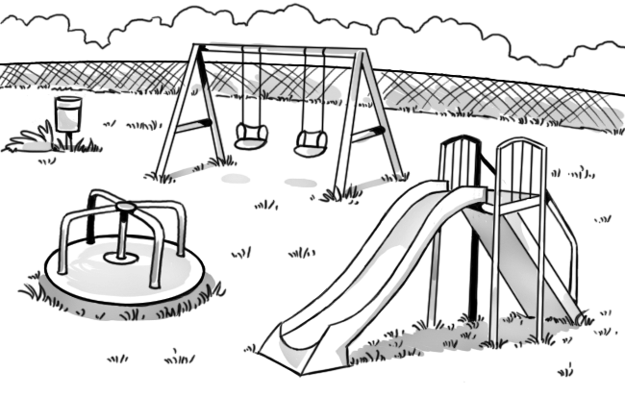 |  | 2. | 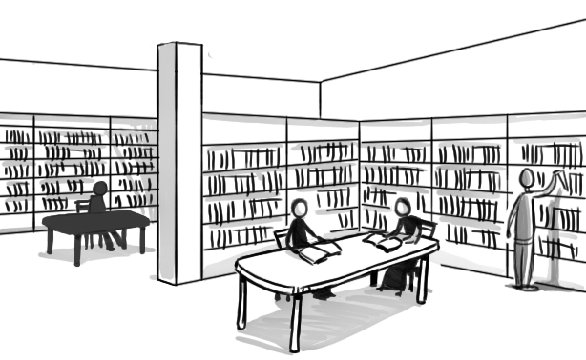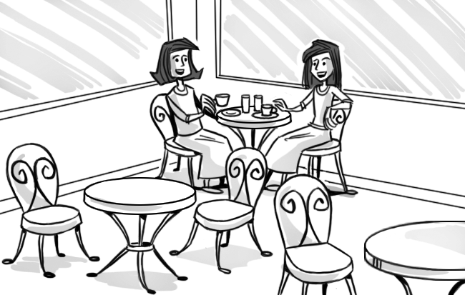
 | pla gr und |  |  | l br ry
4. | 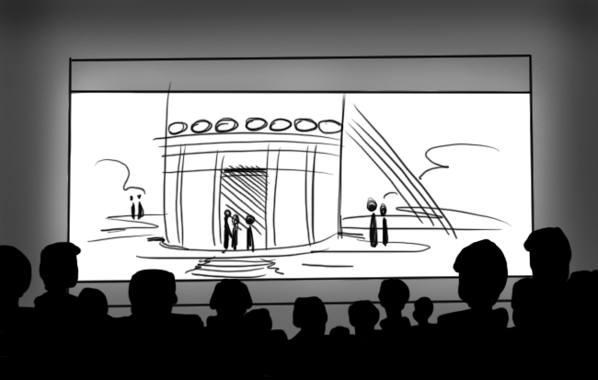 |  | 5. | 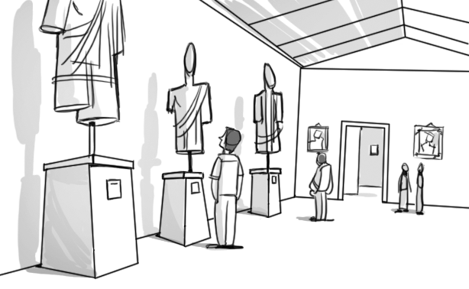
 | mov th ter |  |  | m s um

c é

6.

pl__ __
 |  | 7. | 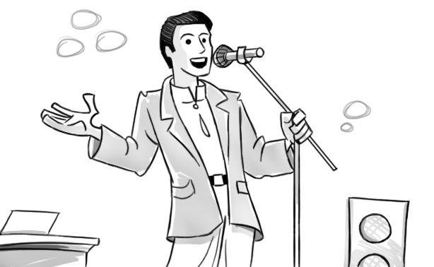 | 8. | 
 |  |  | s n er |  | c n ert
- Circle the correct word.
= always = sometimes = never

1. I sometimes / never () go to the playground.
2. She sometimes / always () gets up at seven o’clock.
3. Mom never / always () goes shopping on Mondays.
4. You and Luke sometimes / always () ride your bikes to school.
5. They never / sometimes () go to the beach in March.
6. We always / sometimes () have lunch at two o’clock.
III. Check () the correct sentence.
1. a. We always catch the bus to school. 
b. We catch always the bus to school. 
2. a. You sometimes go to the beach at June.
b. You sometimes go to the beach in June.
3. a. She never go shopping with her mom.
b. She never goes shopping with her mom.
4. a. Do they ever go to the library?
b. Do they never go to the library?
5. a. I play soccer on Saturdays.
b. I play soccer in Saturdays.
6. a. He gets up on eight o’clock.
b. He gets up at eight o’clock.
IV. Look and read and write.

 Good luck to you! ☺

Examples: How many bears are there? ………one……...
The boy is wearing ………rucksack…..
- The green …………………. is sitting on the rock.
- What is the duck doing? ……………………….......
Now you write one sentence about the picture.
- ……………………………………………………………………………………….

 Good luck to you! ☺
ĐÁP ÁN BÀI TẬP ANH VĂN - LỚP 4

I. Look and complete the words.
1. playground 2. library 3. café 4. movie theater 5. museum
6. play 7. singer 8. concert
II. Circle the correct word.
- sometimes 2. always 3. never 4. sometimes 5. never 6. always
III. Check () the correct sentence.
- a 2. b 3. b 4. a 5. a 6. b
IV. Look and read and write.
- frog
- swimming
- Examples: The girl is waving.
The boy is wearing a shirt and shorts.
The girl is wearing a T-shirt and a skirt.
There are two children in the picture.
There are four animals in the picture.

 The end ☺

